# Linear regression:

## Cost function

$$J(θ)=\frac{1}{2m}[\sum_{i=1}^{m}{{\left(h_{θ}\left(x^{\left(i\right)}\right)-y^{\left(i\right)}\right)}^{2}}+ λ\sum_{j=I}^{n}{θ_{j}^{2}}]$$

## Hypothesis

$$h\left(x\right)=θ^{T}x$$

## Gradient descent algorithm

Repeat until convergence {

$$θ_{0} :=θ_{0}-α\frac{1}{m}\sum_{i=1}^{m}{\left(h_{θ}\left(x^{(i)}\right)-y^{(i)}\right)}$$

$$θ_{j} :=θ_{j}-α\frac{1}{m}\sum_{i=1}^{m}{\left(h_{θ}\left(x^{(i)}\right)-y^{(i)}\right)}x^{(i)}$$

}

α: Learning rate

Plotting J(θ) as a function of number of iterations will show us how good is our chosen α

# Logistic regression:

## Cost function

$$J\left(θ\right)= -\frac{1}{m}\left.[\sum_{i=1}^{m}{y^{\left(i\right)}\left.(\log{h_{θ}\left.{(x}^{\left(i\right)}))\right.}\right.}\right.+ {(1-y}^{\left(i\right)})\left.(\log{h_{θ}(\left.x^{\left(i\right)})\right.}\right.)]+ \frac{λ}{2m}\sum_{j=I}^{n}{θ_{j}^{2}}$$

## Hypothesis

$$h_{θ}\left(x\right)=\frac{1}{1+ⅇ^{-θ^{T}x}}$$

## Notes

$$if y=1, we want h_{θ}\left(x\right)=1, θ^{T}x≫0$$

$$if y=0, we want h_{θ}\left(x\right)=0, θ^{T}x≪0$$

# Support vector machine

## Hypothesis

$$h_{θ}\left(x\right)=1 if θ^{T}x≥0$$

$$h_{θ}\left(x\right)=0 otherwise$$

$$x=\left[\begin{aligned}x_{0} \\ x_{1} \\ . \\ . \\ x_{n}\end{aligned}\right] θ=\left[\begin{matrix}θ_{0} \\ θ_{1} \\ . \\ . \\ θ_{4}\end{matrix}\right]$$

## Cost function

$$J(θ)= \left.C\sum_{i=1}^{m}{[y^{\left(i\right)}\left.{cost}_{1}(θ^{T}x^{\left(ⅈ\right)})\right.}\right.+ {(1-y}^{\left(i\right)})\left.({cost}_{0}(θ^{T}x^{\left(ⅈ\right)})\right.)]+ \frac{1}{2}\sum_{j=I}^{n}{θ_{j}^{2}}$$

## Notes

1. It’s called large margin classifier because:

$$if y=1, we want θ^{T}x≥1 (not just≥0)$$

$$if y=0, we want θ^{T}x≤-1 (not just≤0)$$

# Neural Network

## Feed-forward propagation

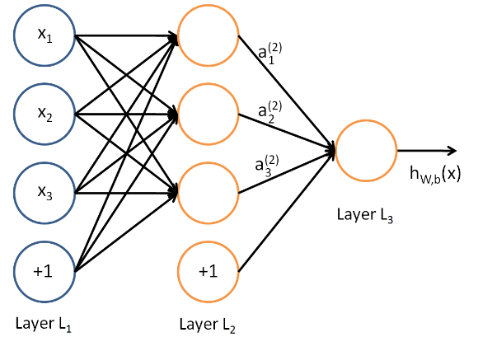

L = 4, s1 = 4, s2 = 4, s3 = 1

in ai(j), j is layer number and i is index

L: total number of layers in network

sl: number of units (not consisting bias unit) in layer l

In binary classification there will be one output unit, y = 0 or 1

In multi-class classification there will be k (> 2) output units, where y is in RK.

E.g. $y\left(i\right)= \left[\begin{aligned}1 \\ 0 \\ 0 \\ 0 \\ 0\end{aligned}\right], \left[\begin{aligned}0 \\ 1 \\ 0 \\ 0 \\ 0\end{aligned}\right], \left[\begin{aligned}0 \\ 0 \\ 1 \\ 0 \\ 0\end{aligned}\right], \left[\begin{aligned}0 \\ 0 \\ 0 \\ 1 \\ 0\end{aligned}\right], \left[\begin{aligned}0 \\ 0 \\ 0 \\ 0 \\ 1\end{aligned}\right]$

## Cost function

$$J\left(θ\right)= -\frac{1}{m}\left[\left.\sum_{i=1}^{m}{\sum_{k=1}^{K}{\left.y_{k}^{\left(\dot{i}\right)}{{log({(h_{θ}(x}^{\left(\dot{i}\right)}))}_{k})}\right.+ (1-y_{k}^{\left(\dot{i}\right)}){{log(1-{(h_{θ}(x}^{\left(\dot{i}\right)}))}_{k})}}}\right.\right]+ \frac{λ}{2m}\sum_{l=I}^{L-1}{\sum_{i=1}^{sl}{\sum_{j=1}^{sl+1}{{(θ_{ji}^{(l)})}^{2}}}}$$

## Backpropagation algorithm

Given training set {(x(1), y(1)), …, (x(m), y(m))}:

Set $Δ_{i,j}^{(l)} :=0$ for all (l, i, j)

For training example i=1 to m {

Set $a(1) :=x(t)$

Perform forward propagation to compute a(l) for l = 2, 3, …, L

Using y(i), compute $δ^{(L)}=a^{(L)}-y^{(i)}$

Compute δ(L-1), δ(L-2), …, δ(2) using

or with vectorization $Δ^{(l)} := Δ^{(l)}+ δ_{i}{(a^{(l)})}^{T}$

}

$$D_{ij}^{(l)} :=\frac{1}{m}Δ_{ij}^{(l)}+λθ_{ij}^{(l)} if j≠0$$

$D_{ij}^{(l)} :=\frac{1}{m}Δ_{ij}^{(l)} if j=0$

### Notes:

The capital-delta matrix is used as an "accumulator" to add up our values as we go along and eventually compute our partial derivative.

The actual proof is quite involved, but, the $D_{ij}^{(l)}$  terms are the partial derivatives and the results we are looking for $\frac{∂}{∂θ_{ij}^{(l)}}J\left(θ\right)= D_{ij}^{(l)}$

# Appendix

m: Number of training examples

n: Number of features

x: Training set

h: Hypothesis

θ: parameters, weights

σ: standard deviation

λ: regularization parameter

## Feature scaling

### Mean normalization

$$x_{i}= \frac{x_{i}-μ_{i}}{range}$$

### Rescaling/Min-max scaling

$$x_{i}= \frac{x_{i}-{min(x}_{i})}{range}$$

### Standardization/Z-score normalization

$$x_{i}= \frac{x_{i}-μ_{i}}{σ}$$

* Gives us mean of 0 and variance of 1

## Sigmoid function

$$g\left(z\right)=-\log{\frac{1}{1+ⅇ^{-z}}}$$

## Optimization algorithms

These algorithms provide optimized solution to calculate cost function and its derivitives.

### Gradient descent

Repeat until convergence {

$$θ_{j}≔θ_{j}-α\frac{∂}{∂θ_{j}}J\left(θ\right)$$

}

α: Learning rate

Plotting J(θ) as a function of number of iterations will show us how good is our chosen α

Slower compared to other optimizers

### Conjugate descent

### BFGS

### L-BFGS

## Normal equation

Solve for θ analytically

$$θ={\left(x^{T}x\right)}^{-1}x^{T}y$$

Slow if n is very large